**ASSIGNMENT NO 11**

**(Group B: MongoDB Assignment No 2)**

**Title of Assignment:** MongoDB Aggregation and Indexing

**Assignment Name: -**. Design & Develop MongoDB Queries using Aggregation and Indexing with suitable example using MongoDB

**Theory: -**

**Indexing:** Indexes support the efficient execution of queries in MongoDB

**Indexing Types**

* **Single field index** only includes data from a single field of the Single Field Indexes documents in a collection.
* **Compound index** includes more than one field of the documents in Compound Indexes a collection.
* **Multikey index** is an index on an array field, adding an index key for Multikey each value in the array. Indexes
* **Geospatial indexes** support location-based searches. Geospatial Indexes and Queries Text Indexes
* **Text indexes** support search of string content in documents.
* **Hashed Index** -Hashed indexes maintain entries with hashes of the values of the indexed field and are used with sharded clusters to support hashed shard keys.

**Index Properties:**

Index Properties -The properties you can specify when building indexes.

1. TTL Indexes The TTL index is used for TTL collections, which expire data after a period of time
2. Unique Indexes A unique index causes MongoDB to reject all documents that contain a duplicate value for the indexed field.
3. Sparse Indexes A sparse index does not index documents that do not have the indexed field.

**Index Creation:**

**Syntax:**

db.CollectionName.createIndex( { KeyName: 1 or -1})

* 1 for Ascending Sorting
* -1 for Descending Sorting

**Index Creation Example:**

* Single: db.stud.createIndex( { zipcode: 1})
* Compound: db.stud.createIndex( { dob: 1, zipcode: -1 } )
* Unique: db.stud.createIndex( { rollno: 1 }, { unique: true } )
* Sparse: db.stud.createIndex( { age: 1 }, { sparse: true } )

**Index Display**

db.collection.getIndexes()

Returns an array that holds a list of documents that identify and describe the existing indexes on the collection.

**Index Drop**

**Syntax:**

1. db.collection.dropIndex()
2. db.collection.dropIndex(index)

**Example:**

1. db.stud.dropIndex()
2. db.stud.dropIndex( { “name" : 1 } )

**Indexing and Querying**

create an ascending index on the field name for a collection records:

* db.records.createIndex( { name: 1 } )

This index can support an ascending sort on name :

* db.records.find().sort( { name: 1 } )

The index can also support descending sort

* db.records.find().sort( { a: -1 } )
* db.stud.findOne( {rno:2} ), using index {rno:1}

**Indexing with Unique:**

* db.collectionname.ensureIndex ( {x:1}, {unique:true} )
* Don’t allow {_id:10,x:2} and {_id:11,x:2}
* Don’t allow {_id:12} and {_id:13} (both match {x:null}

**Aggregation:**

Aggregations operations process data records and return computed results.

Aggregation operations group values from multiple documents together, and can perform a variety of operations on the grouped data

For aggregation in mongodb use aggregate() method.

Syntax:

• >db.COLLECTION_NAME.aggregate(AGGREGATE_OPERATION)

**aggregate() method**

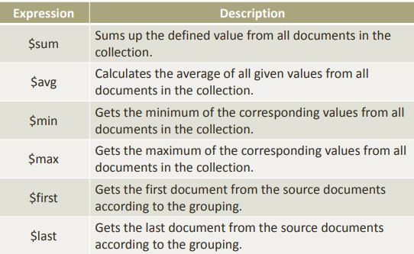

**Possible stages in aggregation**

* $project − Used to select some specific fields from a collection.
* $match − This is a filtering operation and thus this can reduce the amount of documents that are given as input to the next stage.
* $group − This does the actual aggregation as discussed above.
* $sort − Sorts the documents.
* $skip − With this, it is possible to skip forward in the list of documents for a given amount of documents.
* $limit − This limits the amount of documents to look at, by the given number starting from the current positions.
* $unwind − This is used to unwind document that are using arrays. When using an array, the data is kind of pre-joined and this operation will be undone with this to have individual documents again. Thus with this stage we will increase the amount of documents for the next stage.

**Conclusion:**

In this assignment we have studied MongoDB Aggregation and Indexing and solved given Queries using MongoDB.